Space 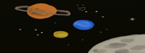 Y1 Knowledge Organiser  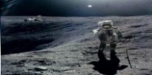
Key Facts
Apollo 11 was the first spacecraft to land on the moon with astronauts.
This moon landing happened on July 20th, 1969.
The American astronauts were Neil Armstrong, Buzz Aldrin and Michael Collins
After he landed on the moon, Neil Armstrong said, “That’s one small step for man, one giant leap for mankind.”
They gathered moon dirt and rocks to bring back to Earth.
Neil Armstrong was an astronaut and a military pilot.
When Neil Armstrong landed on the moon, he planted an American flag.
Apollo 11 took off from the Kennedy space centre in Florida, USA.
It took 4 days to reach the moon.
Vocabulary | Definition
History | Everything that has happened in the past to people or things.
Moon landing | The landing of a spacecraft on the surface of the moon.
Astronaut | A person who is trained to travel in space.
Apollo 11 | The space vehicle that carried the astronauts to the first moon landing.
Lunar module | A small craft used to move between the moon’s surface and orbiting spacecraft.
Moon | The national satellite of the world, reflecting light from the sun.
Earth | The planet where we live – the world.
NASA | The federal agency in charge of sending people to space.
Pilot | A person who flies a plane or spacecraft.

 | Key questions
  Books we recommend :
  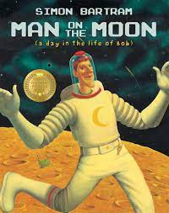 | 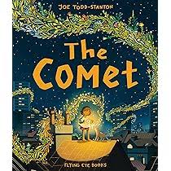
  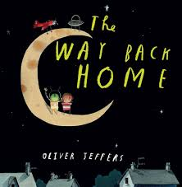 | 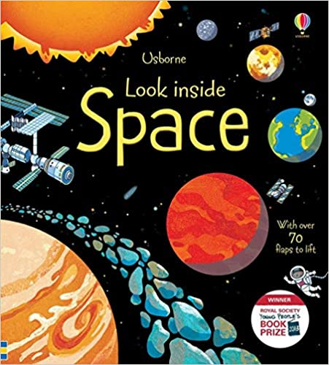
  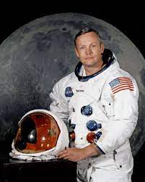 | 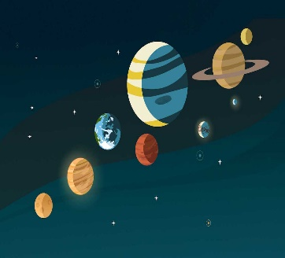
  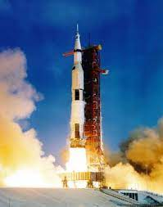 | 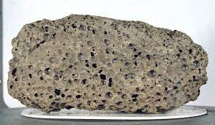
 | Name the first 3 American astronauts to land on the moon.
 | When did the first moon landing take place?
 | What did Neil Armstrong say on the moon?
 | What did Neil and Buzz do on the moon?

