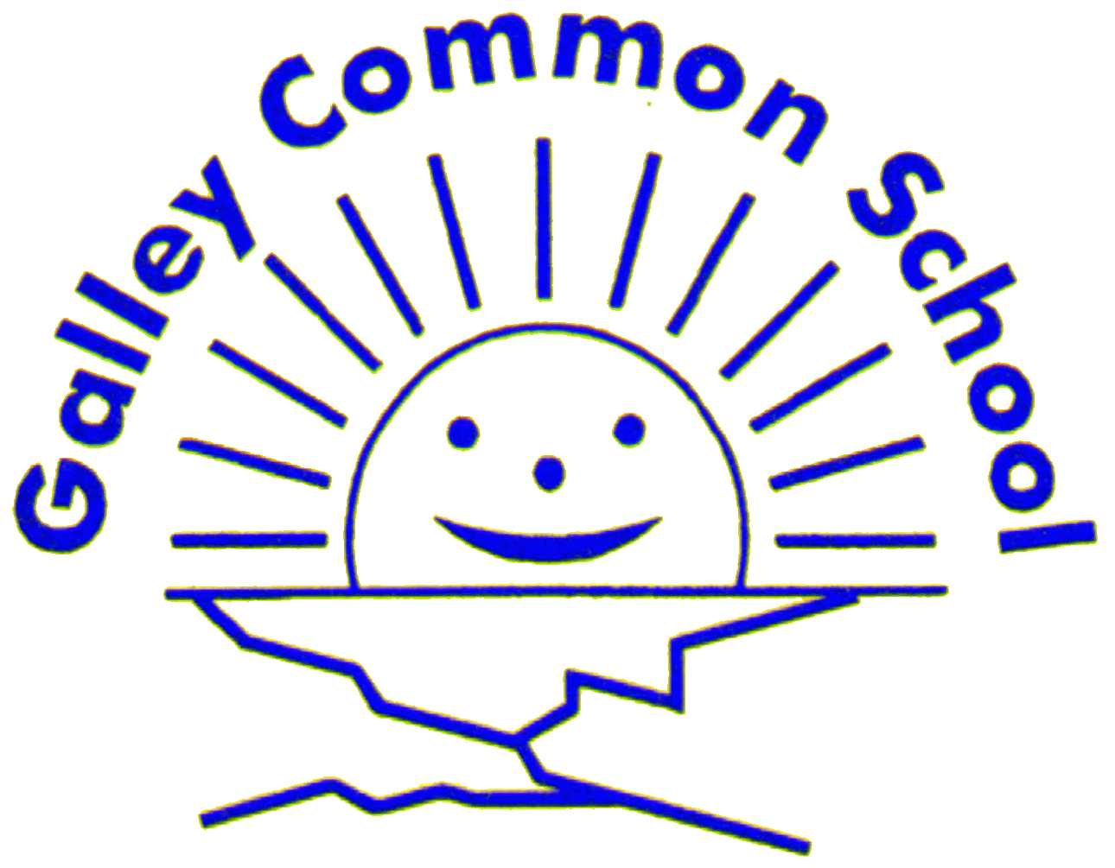Galley Common Infant School
Music Policy
Intent
At Galley Common Infant School, it is our intent to make music an interactive, creative, enjoyable and inclusive learning experience for all of our pupils. Pupils begin their musical journey in Reception and we build upon pupils experiences every year to ensure their musical skills and abilities develop. We encourage children to participate in a variety of musical experiences through which we aim to build up their confidence and self-expression, inspire creativity and help them to develop their musical potential.
Music is a unique way of communicating that can inspire and motivate children. This links directly to our school aim to provide an enjoyable curriculum where children can think creatively. Music is a vehicle for personal expression and creativity and it can play an important part in the personal development of children. Music reflects the culture and society we live in, and so the teaching and learning of music enables children to better understand the world they live in. This links with our school aims of developing children’s values and beliefs of their own and other cultures. It also plays an important part in helping children feel part of a community. We provide opportunities for all children to create, play, perform and enjoy music as well as develop the skills to appreciate a wide variety of musical forms, and to begin to make judgements about the quality of music.
Galley Common Infant School are using the Kapow Primary music scheme to ensure a high quality of music lessons are being delivered to pupils. The intention of the Kapow Primary music scheme is to support children to feel that they are musical and to develop a life-long love of music. The scheme takes particular focus of enabling children to become confident performers, composers and listeners as well as teaching children to respect and appreciate music of all traditions and communities.

Children will develop the musical skills of singing, playing tuned and untuned instruments, improvising and composing music, listening and responding to music. Pupils will develop an understating of the history and cultural context of music that they will listen to and learn how music can be written down. Through music, the Kapow Primary scheme helps children to develop transferrable skills such as team-working, leadership, creative thinking, problem-solving, decision-making and performance skills.

Kapow Primary’s music scheme of work enables pupils to meet the end of key stage attainment targets as outlined in the National Curriculum and the aims of the scheme align with those in the National Curriculum.

Implementation
At Galley Common School the music curriculum ensures pupils sing, listen, play, perform and evaluate. This is embedded in classroom activities and lessons as well as weekly singing assemblies, celebrations and performances. Each year group has two or more opportunities to perform as a whole class/year group which include Christmas performances, class assemblies and the year 2 leaving concert. These experiences give the children the opportunity to showcase their skills in front of a live audience and develop their confidence in musical arts. Extra-curricular activities such as choir and recorder lessons are offered to enhance children’s musical experiences. Children will also experience live musical performances at least once a year through contact with community music groups and professional musical performances (eg. Pantomime and visiting theatre/musical groups).
At all times we focus on accepting and appreciating the efforts of all children, regardless of their natural musical abilities. The children attend a daily assembly where there is the opportunity to listen to music from a range of cultures and genres as well as the children being taught a wide range of hymns and songs, which they perform at assemblies in church and other festivals or celebrations throughout the year. One assembly per week is dedicated just to singing.

Kapow Primary’s music scheme takes a holistic approach to music, in which the individual strands below are woven together to create engaging and enriching learning experiences:

- Performing
- Listening
- Composing
- The History of Music
- The Inter-related Dimensions of Music

Each lesson unit combines these strands within a cross-curricular topic designed to capture pupils imagination and encourage them to explore music enthusiastically. Over the course of the scheme in Reception and KS1, children will be taught how to sing fluently and expressively, and play tuned and untuned instruments accurately and with control. They will learn to recognise and name the inter-related dimensions of music and use these expressively in their own compositions.

The National Curriculum Mapping document shows which units cover each of the National Curriculum attainment targets as well as each of these strands within it. The Progression of Skills and Knowledge document shows the skills which are taught within each year group and how they develop year on year to ensure attainment targets are met at the end of each key stage. Below are just some of the contributions to other curriculum areas.

The contribution of music to other curriculum areas:

English
Music contributes significantly to the teaching of English in our school by actively promoting the skills of reading, writing, speaking and listening. Children develop their language skills through singing songs, with attention to diction, meaning, rhythm and rhyme. Through working with others in a musical setting, children develop their ability to communicate ideas effectively.

Mathematics
Music contributes to the teaching of mathematics in that children who study the structure of music are observing patterns and processes. Talent in music is often linked with talent in mathematics, as the rhythm and structure of music is mathematically based.

Information and communication technology (ICT)
ICT is used in music where appropriate. We have CD ROMs, Powerpoints or videos to support the teaching of music.

Personal, social and health education (PSHE) and citizenship
Music contributes significantly to the teaching of personal, social, citizenship and health education. Through the common goal of making music, children learn to work effectively with other people and build up good relationships. Music is the basis of many social activities and has an important role to play in the personal development of many young people. It has a vital role to play in building self-confidence.

Spiritual, moral, social and cultural development
Listening, creating or performing music can sometimes be a moving and even spiritual experience. We encourage children to reflect on the important effect that music has on people’s moods, senses and quality of life. Children at Galley Common Infant School have the opportunity to encounter music from many cultures and, through their growing knowledge and understanding of the music, they develop more positive attitudes towards other cultures and societies.

Teaching music to children with special educational needs
At our school we teach music to all children, whatever their ability. Music forms part of the school curriculum policy to provide a broad and balanced education to all children. Through our music teaching we provide learning opportunities that enable all pupils to make progress. We do this by setting suitable learning challenges and responding to each child’s different needs.
SEND children who cannot access mainstream music lessons have opportunities to access music through their individualised timetables and carried out by their one to one practitioner.

Impact
During their time in school, children have opportunities to engage in their own musical journey. Our music lessons aim to develop an understanding of culture and history, both in relation to pupils individually, as well as musical cultures from across the world. Children are able to enjoy music, in as many ways as they choose - either as listener, creator and performer. They can discuss music and develop an understanding of how it is created. They can sing, feel a pulse, build rhythmic skills both individually and in a group. They discover their potential for singing and playing and hopefully, with encouragement, seek out opportunities to further develop these skills in the future and continue to enjoy and embrace music in their lives.
Teachers assess children’s work in music by making informal judgements as they observe them during lessons. These assessments are recorded on a cube sheet or through photo evidence. In particular EYFS may use cube sheets and record on tapestry. In KS1 teachers will make both formative and informative assessments through the Kapow Primary scheme assessments. Knowledge organisers for each unit support pupils with a visual to record of key learning and it supports them to recall skills, knowledge and vocabulary.
At the end of the school year the teacher makes a summary judgement about the work of each pupil in relation to the National Curriculum level of attainment. We use this as the basis for assessing the progress of the child and we pass this information on to the next teacher at the end of the year. We record comments for parents on musical progress through the annual report.
After the implementation of the Kapow Primary music scheme, pupils should leave equipped with a range of skills to enable them to succeed in their next school and to be able to enjoy and appreciate music throughout their lives.
The expected impact of following the Kapow Primary music scheme of work is that children will:
- Be confident performers, composers and listeners and will be able to express themselves musically.
- Show an appreciation and respect for a wide range of musical styles from around the world and will understand how music is influenced by the wider cultural, social and historical contexts in which it is developed.
- Understand the ways in which music can be written down to support performing and composing activities.
- Demonstrate and articulate an enthusiasm for music and be able to identify their own personal musical preferences.
- Meet the end of key stage expectations outline in the National Curriculum for Music.

