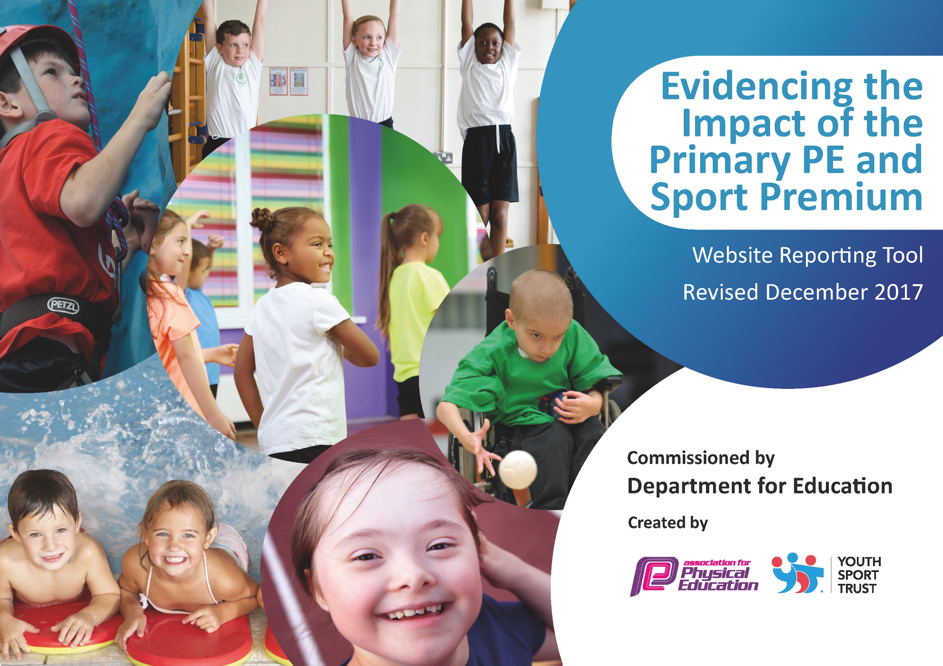

Schools must use the funding to make additional and sustainable improvements to the quality of PE and sport they offer. This means that you should use the Primary PE and Sport Premium to:

- develop or add to the PE and sport activities that your school already offers
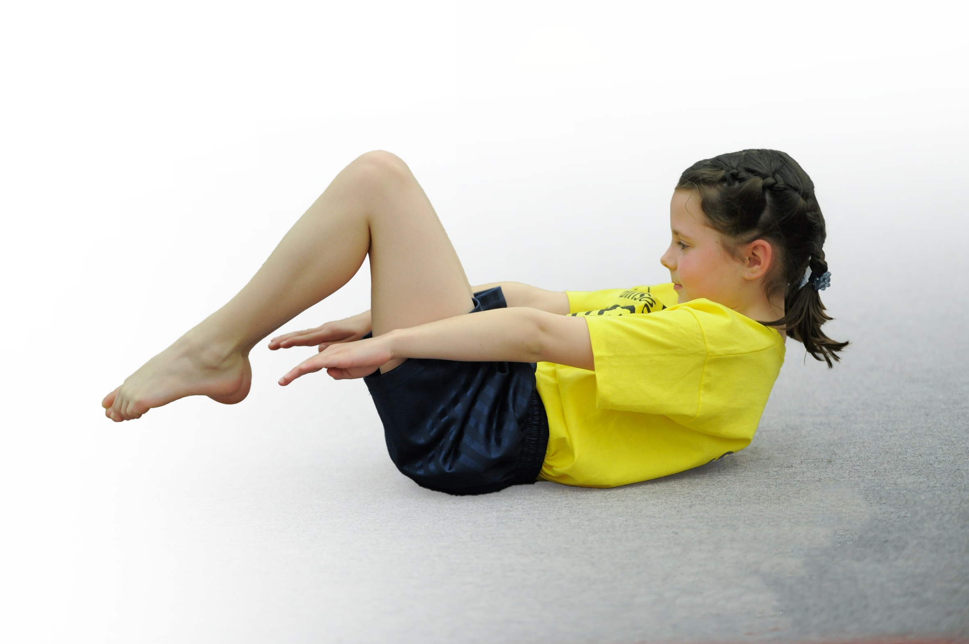
- build capacity and capability within the school to ensure that improvements made now will benefit pupils joining the school in future years

Please visit gov.uk for the revised DfE guidance including the 5 key indicators across which schools should demonstrate an improvement. This document will help you to review your provision and to report your spend. DfE encourages schools to use this template as an effective way of meeting the reporting requirements of the Primary PE and Sport Premium.

We recommend you start by reflecting on the impact of current provision and reviewing the previous spend.
Under the Ofsted Schools Inspection Framework, inspectors will assess how effectively leaders use
the Primary PE and Sport Premium and measure its impact on outcomes for pupils, and how effectively governors hold them to account
for this.

Schools are required to publish details of how they spend this funding as well as on the impact it has on pupils’ PE
and sport participation and attainment.
We recommend regularly updating the table and
publishing it on your website as evidence
of your ongoing review into how you are using the money
to secure maximum, sustainable impact. To see an example of how to complete the table please click HERE.

Support for review and reflection - considering the 5 key indicators from DfE, what development needs are a priority for your setting and your students now and why? Use the space below to reflect on previous spend, identify current need and priorities for the future.

Key achievements to date: | Areas for further improvement:
- Recruiting a sports apprentice.  - New physical equipment - playground trim trail, playground equipment.  - Comprehensive programme of extra-curricular sporting & creative activities Range of ‘Enrichment Sessions’ for children to take part in to learn new skills. (tri golf, curling, archery)  - Dance workshops  - Pre pedal sessions for EYFS  - Change 4 life sessions – focusing on physical wellbeing and health.  - Transition sports festival  - High profile regarding physical well-being, including ‘Fitness Fridays’  - Competition with other Infant schools  - Professional development for teachers alongside expert coach  - Physical interventions throughout the school. | - Continuation increase the participation in competitive sport (in an age appropriate way)  - Broaden access to a range of sports  - Increase confidence, knowledge & skills of teaching staff in PE teaching – REAL P.E training/team teach.

Academic Year:  2025/2026 |  | Total fund allocated:  £ 17,400 |  | Date Updated: July 2026
Key indicator 1: The engagement of all pupils in regular physical activity – Chief Medical Officer guidelines recommend that primary school children undertake at least 30 minutes of physical activity a day in school
School focus with clarity on intended impact on pupils: |  | Actions to achieve: |  | Funding allocated: | Evidence and impact: | Sustainability and suggested next steps:
Active Lunchtimes  KI1  Engagement of all pupils in regular physical activity. |  | Sports Apprentice to support children to keep active and develop their ABC skills during lunchtimes.  Rota to be set up to support children to develop specific skills. Skipping to be included in this.  Purchase/replenish existing play ground equipment.  Training – MDS and Year 2 play leaders to be trained.  Daily Mile to be set up for children each lunch time. |  | Sports Apprentice  £500 – equipment  £200 – play leaders | Throughout the year our sports apprentice has been leading:  - Physical intervention groups  - Active lunchtimes  Range of physical equipment and skills have been used and focused upon.  Play leaders were trained in September. Their training entailed learning a range of playground games which they could then use to engage children in play.  They began by supporting Reception children.  May 2023 Pupil interviews:  “They help me when I have no one to play with.”  “They show me how to play games.” | Children will continue to have access to physical play equipment  N.S .  Set up a rota of playground games/ skills which will be developed and progressed throughout the year.
After School Sport Clubs |  | Sport clubs will be provided for all children. Clubs on offer will be rotated to ensure a broad range for children.  Clubs will be delivered by Positive Impact and our sports apprentice.  Ensure all children are invited and given the opportunity to attend at least one club throughout the year. |  |  | We have had a range of sports clubs this year.  Autumn – Multiskills and Football  Spring – Dance Fit and Multi skills  Summer -Gym and Summer sports  In February 2023 a parent questionnaire went out to gage parents interest in clubs and their views.  Key Findings:  - Reception parents seem VERY Keen! They are not aware of clubs that the school offers. Can we start clubs for Reception children earlier?  - Offering more range of sporting clubs, and potentially an Arts and Crafts club.  - Reasons behind why children do not attend clubs is varying, offering more variety and including Reception would help to boost uptake  Key findings:  - A total of 41 children attended a sports club this half term.  - 60% were boys…….40% were girls.  - Football for Year 1 was fully attended. Multi skills in year 2 was not well attended.  - More boys attended the football club.  - There were 11/33 pupil premium children who attended the club. | Children have accessed a range of sporting clubs this year. They have been well attended.  The questionnaire has given valuable feedback into how we can improve after school clubs.  N.S  Sports apprentice to lead all sport ASC’s. A timetable to be put in place so that clubs can start promptly each term. Reception to be involved in clubs from Spring term.
Health, wellbeing and educational outcomes  KI1  Engagement of all pupils in regular physical activity. |  | Children to access physical opportunities which help to develop their health and wellbeing.  - FS pre pedal - 6 weeks focus on supporting children to develop their balance, co-ordination and gross motor skills. Developing and improving skills to effectively ride a bike.  - Change 4 life sessions for FS and KS1.  Children to be educated about the importance of keeping active, food groups, calories, lifestyle.  - Well being festivals. targeted sports/activity afternoons each with a theme e.g. health & fitness, mental health, resilience. |  | £600 | Prepedal – Children took part in a 6 week block.  Pupil Views:  “It was so much fun! I loved learning how to glide and do the monster steps.”  “It was a bit tricky, I kept wobbling.”  “I loved it, I was so good at lifting my legs up and gliding.”  Change 4 life sessions:  Pupil Views:  “We have been learning about food groups, and what groups are healthy.”  “We have been learning about foods which are healthy and unhealthy, I am going to try and eat a lot more healthy foods and not have Mcdonalds too much.”  “Mr Nixon showed me how to do lots of exercise to burn off food.”  Wellbeing festivals: 1 festival each term focusing on team work, resilience, healthy eating and movements  Pupil Views:  “When we were stacking cups I had to persevere and not give up!”  “we had to make a healthy food plate, mine was delicious.”  “we had to work as a team on the relay race, we had to keep talking to each other to get it done.” | Children have developed their core and co-ordination skills.The skills which children have developed will support them to be able to ride a bike.
Key indicator 2: The profile of PE and sport being raised across the school as a tool for whole school improvement
School focus with clarity on intended impact on pupils: |  | Actions to achieve: |  | Funding allocated: | Evidence and impact: | Sustainability and suggested next steps:
Real P.E scheme to be embedded throughout the school.  Teachers to be confident with delivering the sessions.  The multi ability cogs to be promoted throughout the school. |  | Real P.E  Continue to embed Real P.E in school.  Staff confidence audit to be sent out.  Team teach for all teaching staff to guide through successfully teaching and assessing using Real P.E.  Attendance at Create real PE conference for PE lead |  | £695 for Real P.E membership  Real Gym - £1300  Gym - £845  Dance - £845 | Teachers began teaching P.E using the scheme in September.  Throughout the year all members of staff have attended online training and also in school training for the three areas of P.E – gym, dance, Real P.E.  Monitoring July 2023  Pupil interviews – children were asked about their P.E learning and experience.  Overall children comment:  It is clear children across all year groups really enjoy P.E. All children talked about P.E in a positive way. Children were able to identify why they enjoyed P.E and talk about what they had been doing in P.E recently. It is great to hear pupils recognising different ways teachers are helping them, and that children are aware of when they are doing well/progressing in P.E.  In year 2 children were able to talk about the main skill which they had been learning in their P.E lessons, this is something which we will want to make sure children in year R and year 1 can do too.  Lesson Observations:  Real P.E lessons were observed across the school.  General comment  “Teachers seem to be developing their confidence in using Jasmine. They are using the resources well in the sessions and children seem used to the routines. In each lesson key skills are being taught/explored. The skill is then incorporated in a game/activity towards the end of the session.”  Assessments  Assessments were used to identify children’s starting points. This aided teachers lessons. Good progress was being made across the school. Key groups were identified as needing extra physical intervention. Teachers were then planning for this.  Staff Feedback  All teaching staff were using Real P.E. Information from a staff questionnaire found that teachers were enjoying using the Real P.E scheme of work and that they found the training useful.  “videos are useful….. most activities are engaging……children really develop a skill…….all resources are provided along with music which saves a lot of time”  Teachers found the training really useful:  “It was great to watch how the trainers used the equipment around the room…….I feel like I have a better overall understanding of Real P.E now……I have learnt lots of tips and tricks on how to use the jasmine platform……I feel much more confident teaching using the jasmine platform now.” | Now that teachers are all fully trained in using Real P.E, teachers will continue this throughout next academic year.  Assessment – use the Real P.E assessment wheel to support teachers in tracking assessment in P.E.
Key Indicator 3: Increasing confidence, knowledge and skills of all staff in teaching PE and sporting activities prioritising CPD and training where needed

School focus with clarity on intended impact on pupils: |  | Actions to achieve: |  | Funding allocated: | Evidence and impact: | Sustainability and suggested next steps:
Increased confidence, knowledge and skills of all staff in teaching PE and sport |  | Team Teach Coaching Sessions  P.E training for members of staff.  6 week coaching style training.  Supporting staff to utilise the space in the hall, delivering high quality p.e sessions, assessing, adapting. |  | £1500 | Four members of staff were trained by a highly skilled coach.  Teachers selected a particular unit/element of Real P.E which they needed support with.  Training was focused on maximum engagement, assessment, using apparatus and utilizing the space in the hall, adapting and challenge.  Teacher comments:  “I now have a wider knowledge of ways to adapt lessons to make it more engaging and support all children to master a skill.”  “I feel more confident to set up the hall using a range of apparatus, even if the planning does not suggest I will think carefully about adding equipment to engage and add maximum impact.”  “Training has boosted my confidence to deliver a unit of P.E. I feell more confident to adapt each lesson to suit the needs of my children.”  Lesson Monitoring in Autumn 1 to assess the impact in more detail and to see live the impact training has had on teaching and children’s learning. | - Continue to monitor teaching. Support where needed.  - Offer coaching to other teachers.
Key indicator 4: Broader experience of a range of sports and activities offered to all pupils
School focus with clarity on intended  impact on pupils: | Actions to achieve: |  | Funding  allocated: |  | Evidence and impact: |  | Sustainability and suggested  next steps:
Children to have opportunities to engage in a range of new physical activities and opportunities | Experience days - broaden children’s experiences.  Throughout the school year a range events and experiences for the children to engage in different physical activities  Enrichment sessions  - Year 1 and 2 children to learn new skills in archery, cricket, curling and tri golf.  - FS – Footie Bugs and Pre Pedal  Sessions to teach children new skills.  Children to engage in new physical experiences.  Children to develop their balance, core, coordination and social skills. |  | NWA  KS1 - £1200  FS - £420 |  | Children across the school have taken part in a range of new physical/sporting activities this year.  Pupil questionnaire – year 1 and 2  Enrichment sessions:  Sessions included Boccia, cricket, golf, archery.  Did you enjoy the session?  What did you learn?  How to aim the ball to a target  How to hit a ball with little and big hits to get it to the target.  When I want to aim to just keep looking where I want it to go and then hit it.  What did you enjoy most?  I loved archery, I liked using the arrow and bow to hit the colour.  The archery was so much fun!  I liked doing the golf, my daddy does golf too and I can play with him now.  I liked hitting the sticks (wicket) in cricket.  I loved the Boccia, we had to roll balls into hoop  Pupil questionnaire – Reception  Soccer Tots:  Did you enjoy the session?  What did you learn?  Use the inside and outside of foot to do dribbling.  We learnt to kick it, tried to get it in the goal.  Tackling try to get the ball in the goal and it  We tried to get our feet strong.  We did lots of exercise because it is healthy.  Toe taps on the ball.  dribbling – tapping the ball with the inside.  the tip of the foot is good for kicking.  little kicks and big kicks  I got better and better each time |  | Children have gained experience in a range of physical activities.  Children have gained confidence in new physical activities.  .
  Yes - 8 | No - 0
  Yes - 8 | No - 0
Multi-cultural dance | Improve multi-cultural aspects of PE by involving external providers and delivering multicultural sports activities |  | Education group  £1500 |  | Dance workshops – Diwali, Chinese New Year, Maypole.  Children took part in a dance workshop where they learnt a dance sequence, connected to a theme of a celebration.  Pupil views:  “it was so much fun dancing with the dragon head on…...I loved using the parasols to dance……it was fun dancing around the maypole.” |  | Children developed their dance skills, and also enhanced their understanding of cultural events.
Increased participation in competitive sport. | Included in NWA infant competitions.  Links made with other Infant schools. |  | Included in NWA core offer - £2000 |  | Children were supported to develop their agility skills.  They then worked to achieve their personal best.  During the final session they took part in a competition where their scores were noted and compared to other local schools.  Pupil questionnaire:  “I liked the running, we had to see how fast we could run, and I kept getting better and better each time!”  “we did lots of things like skipping, running, throwing, hopping, we had to see how many we could do.”  Children were awarded trophies and certificates. |  | Children learnt about how to compete against others and achieve their personal best.

