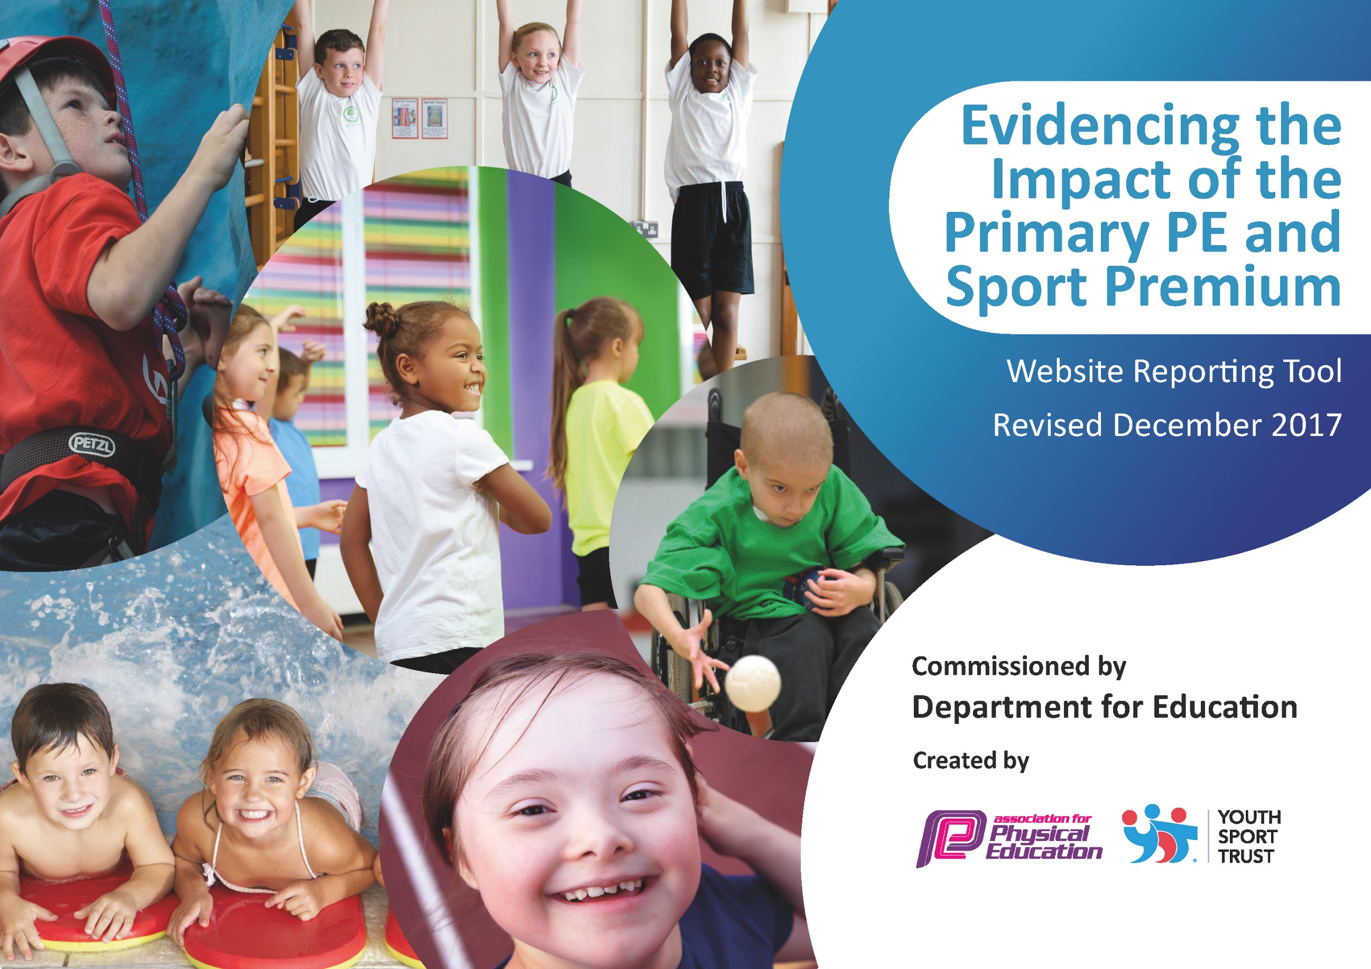

Schools must use the funding to make additional and sustainable improvements to the quality of PE and sport they offer. This means that you should use the Primary PE and Sport Premium to:

- develop or add to the PE and sport activities that your school already offers
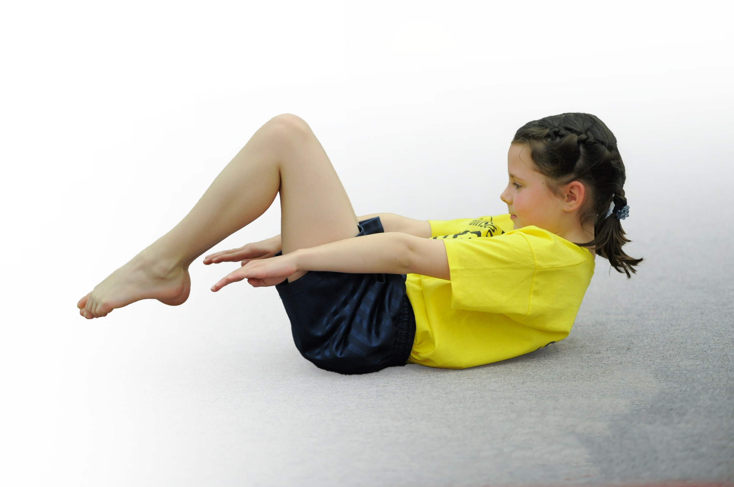
- build capacity and capability within the school to ensure that improvements made now will benefit pupils joining the school in future years

Please visit gov.uk for the revised DfE guidance including the 5 key indicators across which schools should demonstrate an improvement. This document will help you to review your provision and to report your spend. DfE encourages schools to use this template as an effective way of meeting the reporting requirements of the Primary PE and Sport Premium.

We recommend you start by reflecting on the impact of current provision and reviewing the previous spend.
Under the Ofsted Schools Inspection Framework, inspectors will assess how effectively leaders use
the Primary PE and Sport Premium and measure its impact on outcomes for pupils, and how effectively governors hold them to account
for this.

Schools are required to publish details of how they spend this funding as well as on the impact it has on pupils’ PE
and sport participation and attainment.
We recommend regularly updating the table and
publishing it on your website as evidence
of your ongoing review into how you are using the money
to secure maximum, sustainable impact. To see an example of how to complete the table please click HERE.

Support for review and reflection - considering the 5 key indicators from DfE, what development needs are a priority for your setting and your students now and why? Use the space below to reflect on previous spend, identify current need and priorities for the future.

Key achievements to date: | Areas for further improvement:
- Training of sports apprentice.  - Sports apprentice taking PE lessons and sports clubs  - New physical equipment – foam javelins, balls.  - Comprehensive programme of extra-curricular sporting & creative activities Range of ‘Enrichment Sessions’ for children to take part in to learn new skills. (tri golf, curling, archery)  - Dance workshops  - Pre pedal sessions for EYFS  - Change 4 life sessions – focusing on physical wellbeing and health.  - Transition sports festival  - High profile regarding physical well-being,  - Professional development for teachers alongside expert coach  - Physical interventions throughout the school.  - Wide range of Afterschool sports clubs available to the children  - Full use of the REAL PE curriculum improving teachers skills and knowledge when delivering PE  - Wider range of sports clubs and experiences offered | - Use sporting events to grow an interest and love of sport.  - Cross curricular lessons in PE  - Continue to progress with improving confidence, knowledge & skills of teaching staff in PE teaching – REAL P.E training/team teach.  - Sports apprentice to train play leaders to support lunchtime and breaktime activities  - Continuation increase the participation in competitive sport (in an age appropriate way)  - Get sports people to come and talk to the children about their sporting journeys

Academic Year:  2024/2025 |  | Total fund allocated:  £ 17,550 |  | Date Updated: July 2025
Key indicator 1: The engagement of all pupils in regular physical activity – Chief Medical Officer guidelines recommend that primary school children undertake at least 30 minutes of physical activity a day in school
School focus with clarity on intended impact on pupils: |  | Actions to achieve: |  | Funding allocated: | Evidence and impact: | Sustainability and suggested next steps:
Sports Apprentice |  | Sports Apprentice to engage children in physical activity through;  - active play time at lunchtimes  - take P.E lessons  - Leading physical intervention groups.  - sports afterschool clubs  Children will be supported to develop gross and fine motor skills. |  | £13,123 | Throughout the year our sports apprentice has been supporting and taking P.E sessions. To begin he team taught with experienced teachers and coaches before taking sessions himself. He was taught how to use the REAL PE curriculum. He has taken responsibility for assessing children’s learning.  He has lead at least 3 sports afterschool clubs per half term. He has engaged the children with sporting activities at lunchtimes.  May 2025 Pupil interviews:  What do you learn in P.E?  “how I should keep my eyes on the ball.”  How to throw javalins and practice running”  “I’ve3 learnt throwing, Jumping, Climbing and running.”  “We learn lots of different skills in PE lessons.”  June 2025  .”I really enjoy PE lessons”  “they are fun”  “I love PE lessons it is the favorite part of the day”  “We like having different coaching teaching us, different sports.” | N.S  Have them lead physical intervention groups and assess children’s ability.  Apprentice lead more P.E sessions, supporting with pupil development and progress and assessment.  Sports apprentice to teach specific sports to children to align with the children’s interests.
Active Lunchtimes  KS1  Engagement of all pupils in regular physical activity. |  | Sports Apprentice to support children to keep children active and engaged during lunchtimes.  Rota to be set up to support children to develop specific skills. Skipping to be included in this. |  | Sports Apprentice  £0 | Throughout the year our sports apprentice has been leading:  - Active lunchtimes  - Football activities  - Games run for EYFS  Range of physical equipment and skills have been used and focused upon.  May 2025 Pupil interviews:  “I love to play the football at lunchtimes”  “There are activities for us to do.”  “Mr Omar helps us.”  July 2024 Pupil interviews  “we have shooting competitions”  “Football is fun”  “We like playing with the balls. | Give Training – MDS and Year 2 play leaders to be trained.  Children will continue to have access to physical play equipment  Buy more outdoor equipment  N.S .  Use play leaders more effectively and set up a Rota of playground games/ skills which will be developed and progressed throughout the year.
After School Sport Clubs |  | Sport clubs will be provided for all children. Clubs on offer will be rotated to ensure a broad range for children.  Clubs will be delivered by teachers and our sports apprentice.  Ensure all children are invited and given the opportunity to attend at least one club throughout the year. |  | Equipment £122.32  athletics £112.68  Safety | We have had a range of sports clubs this year.  Autumn – Multisports, Yoga  Spring – Scooter club, Multisport, Yoga  Summer – Yoga, Multisport, athletics  Reception have had access to sports clubs from the Spring term.  Pupil interview –  “we get to play with our friends.”  “We learn new sports.”  “The yoga is relaxing.”  Key findings:  Children liked the multisport club as they learnt a variety of skills  They would like specialist clubs e.g. football, basketball to learn specific sports | Children have accessed a range of sporting clubs this year. They have been well attended.  N.S  Continue to give children a range of sporting clubs lead by sports experts.
Health, wellbeing and educational outcomes  KS1/EYFS  Engagement of all pupils in regular physical activity. |  | Children to access physical opportunities which help to develop their health and wellbeing.  - FS pre pedal – intense course - focus on supporting children to develop their balance, co-ordination and gross motor skills. Developing and improving skills to effectively ride a bike.  - Change 4 life sessions for KS1. Children to be educated about the importance of keeping active, food groups, calories, lifestyle.  - Competitions (NWactive lead) |  | £600 - £0 funded by WNactive  £700 - | Prepedal – Children took part in a intensive course.  Children were give instruction by PE experts –  Pupil Views:  “It was so much fun! I don’t have a bike.”  “It was fun learning to ride the bike.”  “I was really good at moving the bike.”  Change 4 life sessions:  Pupil Views:  “We learnt how to exercise well”  “We learnt what things are better to eat for us. Like fruit and vegetables and less sugary foods like chocolate.”  “We learnt about the food groups” | Children have developed their core and co-ordination skills. The skills which children have developed will support them to be able to ride a bike.  N.S.  Wellbeing festivals: encourage children to participate in sport not just for their physical health but mental health too.
Key indicator 2: The profile of PE and sport being raised across the school as a tool for whole school improvement
School focus with clarity on intended impact on pupils: |  | Actions to achieve: |  | Funding allocated: | Evidence and impact: | Sustainability and suggested next steps:
Real P.E scheme to be embedded throughout the school.  Teachers to be confident with delivering the sessions.  The multi ability cogs to be promoted throughout the school. |  | Real P.E  Continue to use Real P.E in school.  Staff confidence audit to be sent out.  Team teach for all teaching staff to guide through successfully teaching and assessing using Real P.E.  Attendance at Create real PE conference for PE lead |  | £695 for Real P.E membership | Teachers and staff are now fully trained on REAL PE which builds skills throughout KS1 giving a focus for each lesson. This gives a clear focus and teachers are commitment is established to improve the quality of existing PE teaching through continuing professional development in PE. All primary pupils improve their health, skills and physical literacy, and have exposure to a broader range of activities. A needs-led staff development plan is established including provision of relevant externally provided training, supporting resources and teaching aids. An evidenced increase in staff confidence and positive perception has led to an  increase in quality of learning and teaching, with individual staff taking greater responsibility for their own future development.  Findings -  Teachers have continued to teach P.E using the REAL PE scheme. They are now confident in using this and adapting any of these for the needs of their children  Monitoring July 2025  Teachers – we feel more confident in the teaching of PE.  Pupil interviews – children were asked about their P.E learning and experience.  Overall children comment:  Children love PE lessons and understand that it is an important subject to learn. They said they found it challenging in a good way. They all knew how to stay safe in these lessons and felt supported in their learning. They knew exercise was good for their bodies.”  Lesson Observations:  Real P.E lessons were observed across the school.  General comment  Teachers are using the videos to effectively model the skills to the children. They are also modeling these physically to the children. They do mini pauses to highlight any children who are performing skills well to show the other children.  Children were engaged in the lessons and understood the learning that they were being asked to do. Children where performing the skills well and teacher were giving live feedback.  Assessments  Assessments were used to identify children’s starting points. This aided teachers lessons. Good progress was being made across the school. Teachers were then planning for this.  Staff Feedback  All teaching staff were using Real P.E. Information from a staff questionnaire found that teachers were still enjoying using the Real P.E scheme of work. New teachers would like some CPD in the scheme of work to more effectively use it in lessons.  Teachers are liking using the videos to support their modeling and teaching.”  “teachers know the sequence of lessons and how they flow to improve the skills.” | Teachers will continue to use REAL PE as it is embedded into the curriculum – More training required for new staff members and refresher on certain aspects of the curriculum to improve existing teachers’ knowledge.  Assessment –  Summative assessments each lesson to see the improvements.  NS –  Refresher training for all staff to keep the confidence of staff learning and CPD addressed. New staff to learn the RealPE scheme of work.
CPD – Staff AfPE |  | Safety training for all teaching staff for PE – safety guidelines and expectations of pupils in lessons. Delivery of sport in a safe and purposeful way. Linked to school policy. |  | £40 | Staff meeting was held to highlight new safety points in the documentation. Staff were reminded of standard of teaching in PE and expectations of Staff and pupils in PE sessions. | N.S. –  Yearly staff meetings to keep teachers up to date with safety procedures related to PE lessons
Key indicator 4: Broader experience of a range of sports and activities offered to all pupils
School focus with clarity on intended  impact on pupils: | Actions to achieve: |  | Funding  allocated: |  | Evidence and impact: |  | Sustainability and suggested  next steps:
Children to have opportunities to engage in a range of new physical activities and opportunities | Experience days - broaden children’s experiences.  Throughout the school year a range events and experiences for the children to engage in different physical activities  Enrichment sessions  - Year 1 and 2 children to learn new skills in archery, cricket, curling and tri golf.  - FS – Pre Pedal  Sessions to teach children new skills.  Children to engage in new physical experiences.  Children to develop their balance, core, coordination and social skills. |  | NWA  KS1 - £600 |  | Children across the school have taken part in a range of new physical/sporting activities this year.  Pupil questionnaire –  Enrichment sessions:  Sessions included Boccia, cricket, golf, archery.  All children questioned enjoyed the session and said they would like to do them again.  What did you learn?  How to use a bow and arrow  How to shoot where you aim a bow.  How to hold a bow and arrow correctly.  How to hold a golf club and hit the ball.  Throwing the ball accurately (boccia) .  How to be more accurate.  What did you enjoy most?  Learning a new sport.  I loved archery, using a bow was really fun.  I liked doing the golf, I can use the stick to hit the ball.  I loved the Boccia, the balls were different to what we have used before.  Pupil questionnaire – Reception  Pre-Pedal  I liked learning riding a bike.  I haven’t done this before it was fun.  It helped me balance. |  | Children have gained experience in a range of physical activities.  Children have gained confidence in new physical activities.  NS  Give more skill based lessons to EYFS – Footie bugs or Rugby tots.  Books session again to keep the enrichment ongoing next.  .
Multi-cultural dance | Improve multi-cultural aspects of PE by involving external providers and delivering multicultural sports activities |  | Education group  £1157 |  | Dance workshops – St Patrick dance, Chinese New Year, Maypole.  Children took part in a dance workshop where they learnt a dance sequence, connected to a theme of a celebration.  EYFS - Dance lessons in Dawali dance.  Pupil views:  “I loved using the chinse umbrella…...I liked watching the person perform……the maypole was so fun….. the ribbons were fun to tie around.” |  | Children developed their dance skills, and also enhanced their understanding of cultural events.  NS  Asking local dance teacher to do more enrichment sessions throughout the curriculum by doing dance workshops for each year group. Extra sessions and could be less expensive than Education group.
Increased participation in competitive sport. | Included in NWA infant competitions.  Links made with other Infant schools. |  | Included in NWA core offer - £1000 |  | Children were supported to develop their agility skills.  Children were given an opportunity to experience a lot of different skills.  They then worked to achieve their personal best.  During the final session they took part in a competition where their scores were noted and compared to other local schools.  Pupil questionnaire:  “I liked trying to beat my scores.”  “Seeing how fast we could run, and I kept getting better and better each time, was fun!”  “The distance throwing was really fun.”  Children were awarded certificates. |  | Children learnt about how to compete against others and achieve their personal best.  NS - Attendance of the celebration of sports competitions at the end of the year.

